# Blood Splatter: The Point of Origin

|  |  |
| --- | --- |
| Topic | Forensic Science |
| Program | Brown Science Prep |
| Developed by | Joseph Paliotti |
| Developer Type | High school teacher |

## Overview / Purpose / Essential Questions

* How can physics and image analysis tools be used to solve crimes?
* Can the physical properties of a fluid be used to track where it came from?

Time Required to Complete Activity: 45 minutes

## Performance / Lesson Objective(s)

The goal of these two laboratory lessons is to learn how knowledge of mathematics, physics, and image analysis software can be used in combination to investigate evidence at a crime scene, like blood splatter. By the end of this activity, students will be able to:

1. Determine the direction of blood flow based on the shape of the droplet splatter.
2. Calculate the angle of impact for individual drops of blood spatter.
3. Use lines of convergence to help determine the position of the victim when the wound was inflicted.
4. Use the Law of Tangents to calculate the height above floor level where the wound was inflicted.

## Lesson Materials

* Activity Sheet for Activity 7-6
* 1 metric ruler
* 1 colored pencil or marker
* 1 pencil
* calculator with tangent function
* tangent tables (optional)

## Lesson Motivation

Blood-spatter analysis helps crime-scene investigators reconstruct what happened at the crime scene. Using only blood-spatter analysis, you may be able to recognize the events leading up to the crime. Although crime scene investigators may arrive at the crime scene after the victim and witnesses are no longer present, they still need to determine what happened. Often several witnesses give different accounts of the crime. Which witness is providing an accurate description of what really happened?

During the investigation, the crime-scene investigators need to determine if the evidence, in this case the blood spatter, matches the description given by the witnesses, the suspect(s), and the victim(s). In domestic abuse cases, the victim of domestic abuse may tell a false story to try to protect the abusing partner. A victim may state that a head injury occurred as a result of falling down stairs. However, if the blood-spatter patterns are inconsistent with this type of injury, then what type of injury did cause the blood spatter? What actually happened? Is a witness lying? Further investigation is required when the blood-spatter evidence tells a different story than the witness’s account of the incident.

## Lesson Activities

In this activity, students analyze blood spatter in three dimensions. By noting the shape of the droplet of blood, the direction in which the blood was moving can be determined. The size of the blood spatter will provide some indication of the velocity of the blood when it hit a surface. By examining at least two drops of blood spatter, the location of the injured person can be determined so long as the injury occurred in two dimensions (lines of convergence). The distance from the area of convergence to the drop of blood can easily be measured. To determine the point of origin, or height from the impact surface, further calculations are necessary. By measuring the width and length of a single drop of blood, the angle of impact can be assessed. By using the Law of Tangents, the height from which the blood fell, or the point of origin for the blood, can be calculated.



## Procedure

**Math Review:** A right triangle

* Contains one 90-degree angle.
* The hypotenuse is the longest side of a triangle, opposite the 90-degree angle (right angle).
* The opposite side to an angle is the side directly opposite the angle of interest.
* The adjacent side to an angle is the side closest to the angle that is not the hypotenuse.

**Laboratory exercise 1:** Examine the relationship between height and velocity as well as height and blood drop diameter for falling blood drops, both vertically and at an angle.

*Procedure –* Using a dropper, allow a single drop of blood to drop from five different heights: 5 cm, 25 cm, 50 cm, 75 cm, and 100 cm onto a sheet of paper. Record the following information in the data table below:

* 1. Sketch of the drop.
  2. Time it takes from releasing the drop to impact the ground.
  3. Final velocity of the drop.
     1. Use the equation vf = vi+at, where *vf* is final velocity, *vi* is initial velocity (0 m/s),
     2. *a* is acceleration (9.8 m/s2), and *t* is the time it took the drop to fall.
  4. Use Image-J to determine the diameter of the drop.

Complete the data table below:

|  |  |  |  |  |  |
| --- | --- | --- | --- | --- | --- |
| **Blood Drops** | | | | | |
| **Distance** | **0.05 m** | **0.25 m** | **0.50 m** | **0.75 m** | **1.00 m** |
| **Sketch of Drop** |  |  |  |  |  |
| **Time (s)** |  |  |  |  |  |
| **Final Velocity (m/s)** |  |  |  |  |  |
| **Diameter (m)** |  |  |  |  |  |

1. Were you able to distinguish differences in shape between the 5 cm and 25 cm drop? Explain any differences. **(1 point)**
2. Using your data, complete the following graphs: **(2 points each)**
   1. Time vs. Distance
   2. Velocity vs. Distance
   3. Diameter vs. Distance
3. Examine your Time vs. Distance graph. What is the relationship between the time and the distance the blood drop fell? **(1 point)**
4. Examine your Velocity vs. Distance graph. What is the relationship between the final velocity and the distance the blood drop fell? **(1 point)**
5. Using your graph, determine the final velocity of a blood drop if it fell 0.65 meters. **(1 point)**
6. Examine your Diameter vs. Distance graph. What is the relationship between diameter of the blood drop and the distance the blood drop fell? **(1 point)**

*Procedure –* Using the dropper, release a single drop of blood from 1.25 m and 1.75 m onto a sheet of paper.

Draw each blood drop in the table below. Be sure to take the size of the drop into consideration.

|  |  |
| --- | --- |
| **Blood Drops** | |
| **1.25 m** | **1.75 m** |
|  |  |

1. In terms of velocity, why did the drops (in comparison to each other) look the way they did? **(2 points)**

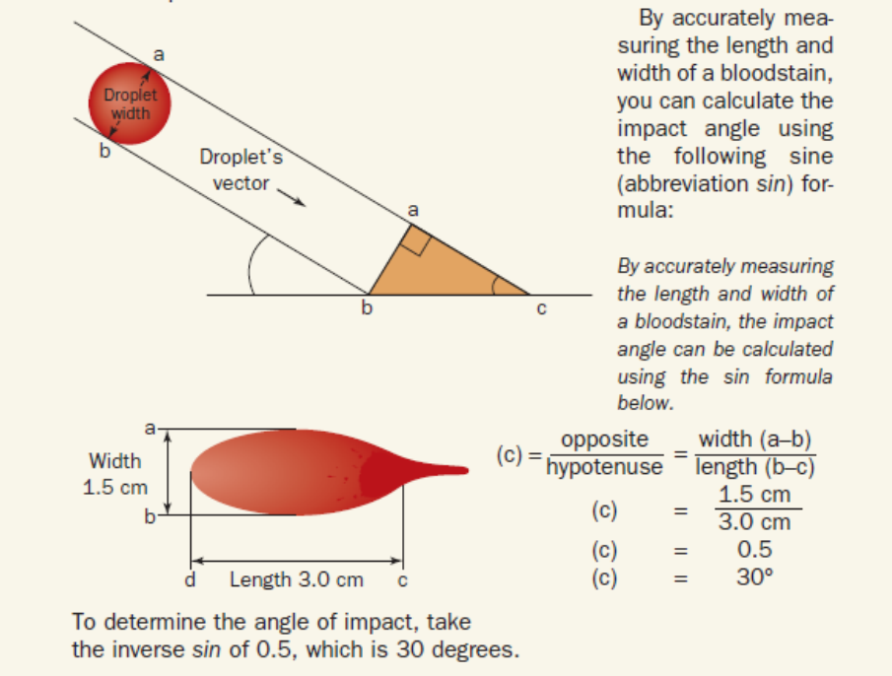Name: ____________________ Date: ____________ Block: ________

*Procedure –* Using a protractor and a dropper, allow a single drop of blood to drop from three angles: 25°, 45°, and 75° onto a sheet of paper. Record your data and answer the questions below.

Draw a picture of each blood drop in the table below:

|  |  |  |
| --- | --- | --- |
| **Drop Angles** | | |
| **25°** | **45°** | **75°** |
|  |  |  |

1. Determine the relationship between the angle of impact and the shape of the blood drop. **(1 point)**
2. Using the equation sin c = width / length, calculate the angle for each trial (*show your work* in the space below). Did your calculated angle match the actual angle? **(3 points)**

|  |  |  |
| --- | --- | --- |
| **Drop Angles Calculations** | | |
| **25°** | **45°** | **75°** |
|  |  |  |
| **Did the calculated angled match the actual angle?** | | |
|  |  |  |

Name: ____________________ Date: ____________ Block: ________

*Procedure –* Use observations and calculations to determine how drop shape can be used to determine a blood drop’s velocity and impact angle.

1. Figure 1 shows blood spatter at low and high velocity from 10 cm and 20 cm. Indicate which spatter from each height was *low velocity* or *high velocity*. **(2 points)**

|  |  |  |  |  |
| --- | --- | --- | --- | --- |
| **10 cm** | **A** |  | **B** |  |
| **20 cm** | **C** |  | **D** |  |

1. How were you able to distinguish between high and low velocity? **(1 point)**
2. Figure 2 shows blood drops from different heights: 1 cm, 10 cm, 30 cm, 40 cm, 50 cm, 75 cm, and 100 cm. Rank the blood drops in order from lowest to highest. **(3 points)**

1 cm - _________ 10 cm - _________ 30 cm - _________ 40 cm - _________

50 cm - _________ 75 cm - _________ 100 cm - _________

1. In terms of *velocity* and *drop shape*, how were you able to determine the drop height order? **(1 point)**

Velocity:

Drop Shape:

1. Figures 3 and 4 show blood spatter at different angles. Calculate the angles for each using the equation: sin c = width / length. Show your work in the space below. **(6 points)**

|  |  |  |  |  |  |
| --- | --- | --- | --- | --- | --- |
| **A** | **B** | **C** | **D** | **E** | **F** |
| **Calculations** | | | | | |
|  |  |  |  |  |  |
| **Angles** | | | | | |
|  |  |  |  |  |  |

**Laboratory exercise 2:** To recreate a crime scene from several drops of blood, students will need to perform several steps.

1. Determine the direction of blood flow in the drops that follow with an arrow next to the droplet. If the blood drop is circular, then the blood fell at a 90- degree angle. If it is not circular, then the angle of impact was less than 90 degrees. The elongated end of a drop of blood points to the direction in which the blood was moving.



1. From several drops of blood, determine the area of convergence by drawing lines through each of the blood droplets and noting where the lines intersect.
2. Determine the direction of the blood when it struck an object.
3. Draw your line in the direction opposite to the direction in which the blood was moving.
4. The area where the lines intersect represents the area of convergence or the approximate location where the person was located when the blood droplets formed.



1. Once the area of convergence have been determined, measure the distance from the area of convergence to the edge of the drop of blood when it first impacted a surface. This distance is indicated in green.

*Recall the diagram of a right triangle. This green line next to the angle of impact is known as the adjacent side.*



1. Next determine the angle of impact for each droplet of blood. Select one of the blood droplets and determine the angle of impact for that drop of blood. To calculate the angle of impact, use the Law of Sines. Remember, measure the length of the blood droplet, do not include the thin extension of the leading edge.



1. Using the Law of Tangents to solve for height. Going back to the right triangle and adding the angle of impact, the height from where the blood originated can be determined. The height of the source of blood is the side opposite the angle of impact. To solve for the height (or the side opposite the angle of impact), apply the Law of Tangents.





Example:

Crime-scene investigators noted blood spatter on the floor of the kitchen. The investigators drew lines of convergence and measured the distance from the area of convergence to the front edge of a drop of blood. That distance was recorded as 5.75 feet. After measuring the length and width of the blood droplet and using the Law of Sines, it was determined that the angle of impact was 27 degrees. The police wanted to determine the point of origin, or the height from the floor where the person was bleeding.



Solution:

Tan = Opposite/Adjacent = Height/Distance

Tangent of the blood-spatter angle = Height of the wound/Distance from blood to area of convergence

Substituting values in the equation

tan 27° = Height of wound/distance

tan 27° = height/5.75 ft.

***Consult a calculator or tangent chart***

tan 27° = h/5.75 feet

.5095 = h/5.75 feet

**Solving for h:**

h = ~2.9 feet is the distance above the ground where the wound began bleeding

**Problems to Solve:**

Make the calculations for each of the following problems and label the right triangle for each blood-spatter drop. Include angle of impact, distance to area of convergence (d), and height (h) above the ground.

**Problem 1:**

Refer to Blood-spatter Sketch 1. From these drops of blood, determine the point of origin of the blood. To determine the point of origin, students will need to:

* + 1. Determine the direction in which the blood was traveling.
    2. Draw lines of convergence.
    3. Draw a small circle around the intersection of the lines of convergence to indicate the area of convergence.
    4. Measure the distance in millimeters from the area of convergence to the front edge of the blood spatters using a metric ruler.
    5. Using the scale of 1 mm = 0.2 feet, determine the actual distance.
    6. Using blood droplet 1, determine the angle of impact:

1. Measure the width and the length of the blood droplet.
2. Divide the width/length ratio for the blood droplet.
3. Using a calculator and the inverse sine function, determine the angle of impact for that blood droplet.
   * 1. Using the Law of Tangents, determine the point of origin or the height of the source of blood for droplet 1.



**Problem 2:**

A 30-year-old man was found shot in the head in his garage. The suspect claims he was being attacked and shot the victim in self-defense. Refer to Blood-spatter Sketch 2 on the next page. From these drops of blood, determine the point of origin of the blood. To determine the point of origin, you will need t0:

* 1. Determine the direction in which the blood was traveling.
  2. Draw lines of convergence.
  3. Draw a small circle around the intersection of the lines of convergence to indicate the area of convergence.
  4. Measure the distance in millimeters from the area of convergence to the front edge of the blood spatter.
  5. Use the scale of 1 mm = 0.3 feet to determine the actual distance.
  6. Use blood droplet 1 to determine the angle of impact:

1. Measure the width and the length of the blood droplet.
2. Divide the width/length ratio for the blood droplet.
3. Using a calculator and the inverse sine function, determine the angle of impact for that blood droplet.
   1. Use the Law of Tangents to determine the point of origin or the height of the source for blood droplet 1.



**Problem 3:**

A victim was found at the foot of a ladder with a chest wound. What is the approximate height of his wound when he was shot? Refer to the blood spatter sketch below. From these drops of blood, determine the point of origin of the blood. To determine the point of origin, you will need to:

1. Determine the direction in which the blood was traveling.
2. Draw lines of convergence.
3. Draw a small circle around the intersection of the lines of convergence to indicate the area of convergence.
4. Measure the distance from the area of convergence to the front edge of the blood spatter (droplet #3) using a millimeter ruler.
5. Use the scale of 1 mm = 1.5 feet to determine the actual distance.
6. Use blood droplet 3 to determine the angle of impact.
   1. Measure the width and the length of the blood droplet.
   2. Divide the width/length ratio for the blood droplet.
   3. Using a calculator and the inverse sine function, determine the angle of impact for that blood droplet.
7. Use the Law of Tangents to determine the point of origin or the height of the source of blood for droplet 3.



## Wrap up / Conclusion

Ask students whether this forensic evidence is compelling and conclusive.

Ask students what disciplines (e.g., biology, math, physics, computer science, etc.) are used to properly assess blood splatter.

## Supporting Web Information

[NIH ImageJ](https://imagej.nih.gov/ij/download.html) – free image analysis program for measuring shapes and sizes

## Pre Assessment Plan

Ask how the shape of a blood droplet can be used to determine where it came from.

What scientific disciplines would be useful for analyzing blood splatter?

## Post Assessment Plan

Repeat questions of pre-assessment plan

Ask how this same approach could be used for analyzing splatter paths in three dimensions.

## Alignment Info

|  |  |
| --- | --- |
| Audiences | High school students |
| STEM Area(s) | Physics |
| Standard(s) | *Physical Sciences (RI GSE) PS3.9-11.8a*  Students demonstrate an understanding of forces and motion by … predicting and/or graphing the path of an object in different reference planes and explain how and why (forces) it occurs.  *Physical Sciences (RI GSE) PS3.9-11.8b*  Students demonstrate an understanding of forces and motion by … using modeling, illustrating, graphing explain how distance and velocity change over time for a free falling object.  *Physical Sciences (RI GSE) PS3.9-11.9a*  Students demonstrate an understanding of forces and motion by … explaining through words, charts, diagrams, and models the effects of distance and the amount of mass on the gravitational force between objects (e.g. Universal Gravitation Law).  *Physical Sciences (RI GSE) PS3.9-11.9b*  Students demonstrate an understanding of forces and motion by … using Newton’s Laws of Motion and the Law of Conservation of Momentum to predict the effect on the motion of objects. |
| Activity Type(s) | Hands-on laboratory exercise |
| Grade Level(s) | High School |
| Version | 1 |
| Created | 09/01/2015 |
| Updated | 08/15/2017 |